ATTENUATION & DISPERSION LOSSES

Objective: To demonstrate the principle effects of losses in the transmission line
attenuation and dispersion.

List of Equipment:
- Transmission Line Demonstrator (TLD)
- Function Generator
- Oscilloscope
Theory:
The propagation constant is separated into two components that have very different effect on signal
γ = α + jβ
α = attenuation constant
β = Phase constant

The real part of the propagation constant is the attenuation constant and is denoted by α (alpha). It causes signal amplitude to decrease along a transmission line. The natural units of the attenuation constant are Nepers/meter, but we often convert to dB/meter in microwave engineering. The phase constant is denoted by β (beta) adds the imaginary component to the propagation constant. It determines the sinusoidal amplitude/phase of the signal along a transmission line, at a constant time. The phase constant's "natural" units are radians/meter, but we often convert to degrees/meter.
To quantize the RF losses in transmission lines we need to calculate the attenuation constant α. The attenuation constant can be broken down into at least four components, one representing metal loss which is proportional to metal’s resistivity, one representing dielectric loss due to loss tangent, one due to conductivity of the dielectric, and one due to stray radiation.
The general solutions of the second-order, linear differential equation for voltage V and current I are:
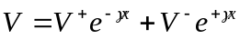 (7)
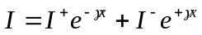 (8)
V⁺, V⁻, I⁺, I⁻ are constants (complex pastors). The terms containing e^{-γx} represent waves travelling in +z direction, terms containing e^{+γx} represent waves travelling in -z direction.
Since
e^{-γx} = e^{-αx} e^{-jβx} (9)
α determines the attenuation along the line, and β determines the phase shift along the line.
Another loss which occurs in transmission line is “dispersion”. The word "dispersion" comes from the idea that the different frequency components of a complex signal which is propagating along a line, travel at different speeds, and spread out in distance along the line or "disperse". A complex wave velocity leads to wave attenuation; a frequency-dependent wave velocity is called "dispersion" and lines having this property are called "dispersive lines".

Procedure:
Attenuation of Sine wave
- Click the “Run continuously” button.
- Connect the source to Transmission line demonstrator as shown in figure1.
- Set the frequency of the source by given slider and the amplitude by the knob.
- The attenuation (dB) can be varied by the slider given in “Transmitter Line Demonstrator” window.
- Due to attenuation amplitude of the wave is reduced, as can be seen in TLD window

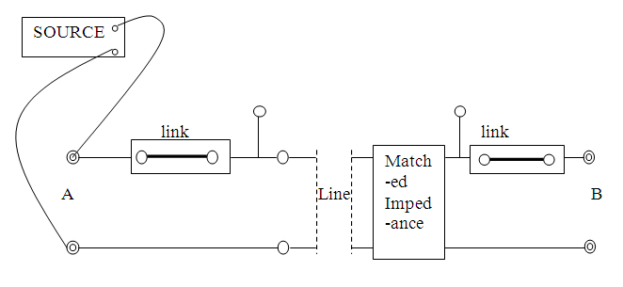

Figure 1 Experiment arrangement for Attenuation and Dispersion
Dispersion
- Click the “Run continuously” button.
- Put the switch in “ON” mode to run the simulation.
- Source is connected to Transmission line demonstrator, which is connected with an oscilloscope. In oscilloscope completely dispersed pulse is shown.
- “Delay Time” is an option for delay, given in Transmission line demonstrator window.

Discussions:
- What are the causes of attenuation?
- Discuss about the variation in the value of attenuation with frequency?
- What is a group velocity? How do you define group delay?
- How does dispersion affect small bandwidth and large bandwidth signals?

References:
- E.C. Jordan and K.G.Balmain, ‘Electromagnetic wave Radiating Systems’ 1968.
- A.W. Cross, ‘Experimental Microwaves’, 1977.
- Mathew N. O. Sadiku, “Elements of Electromagnetics”, Oxford University Press, 2001.

